Attribute | Parameter Value
Product Catalog | Slide Switch
Rated Current (DC) | 3A
Rated Voltage (DC) | 125V
Rated Current (AC) | 3A
Rated Voltage (AC) | 125V
Circuit Structure | SPDT (Single Pole Double Throw)
Mounting Method | Right-angle Pin
Mechanical Life | 10000
Switch Color | Black
Slider Shape | Rectangular Column Shape
Pin Style | PC pin
Switch Length | -40℃~+85℃
Switch Length | 13.5mm
Switch Width | 6.6mm
Switch Height | 6.3mm
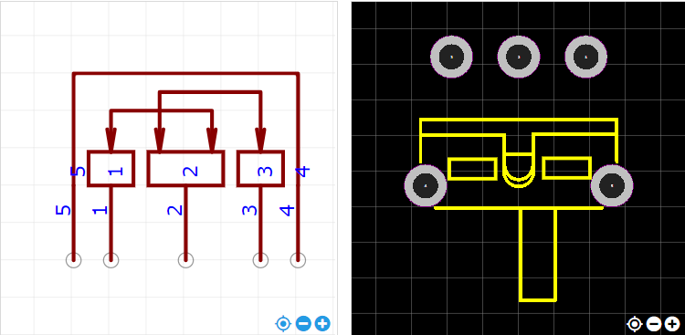
https://item.szlcsc.com/724367.html

